Gap Analysis:
Intra-professional Collaborative Practice among Nurses, Second Edition, January 2016
Work Sheet

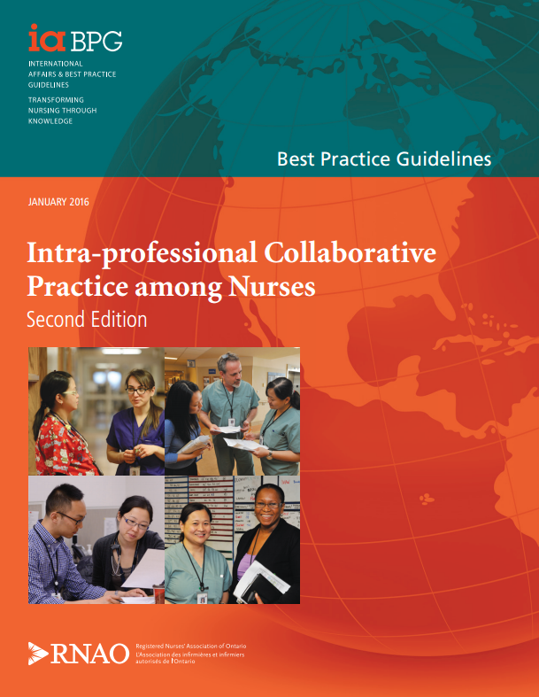
This guideline can be downloaded for free at:
http://rnao.ca/bpg/guidelines/intra-professional-collaborative-practice-among-nurses

The RNAO Leading Change Toolkit 3rd Edition
https://rnao.ca/leading-change-toolkit

Date Completed:
Team Members participating in the Gap Analysis:

RNAO Healthy Work Environment Best Practice Guideline Recommendations | Met | Partially Met | Unmet | Notes  (Examples of what to include: is this a priority to our home, information on current practice, possible overlap with other programs or partners)
Individual/Team Recommendations
1.1 Nurses develop an understanding of the roles, values and behaviours that support intra-professional collaborative practice by:
- learning about the attributes of supportive teams; and
- demonstrating willingness to work effectively with others.
(Level of Evidence = IV)
1.2 Nurses acquire and demonstrate the attributes of team work through:
- learning about the impact of interpersonal factors on the team;
- team building activities;
- demonstrating their commitment to the team; and
- communicating effectively and openly, based on a clear understanding of their own roles scope of practice, and those of other team members.
(Level of Evidence = IV)
1.3 Nurses initiate collaborative processes to improve patient/client outcomes, in particular when the acuity of the patient/client is increasing:
- in circumstances when a diagnosis has not been established, the patient should be assigned to an RN to ensure the continuity of care
(Level of Evidence = IV)
1.4 Nurse managers model effective team behaviour and demonstrate power-sharing.
(Level of Evidence = IV)
1.5 Nurses enhance the quality of work environments and improve outcomes for patients/clients by establishing processes and structures to promote intra-professional collaboration. Nurses should do this by:
- collaboratively establishing processes for shared decision making in a variety of circumstances; and
- introducing non-hierarchical, democratic working practices.
(Level of Evidence = Ia, IIb, IV)
1.6 Nurses promote open, honest and transparent communication by
- promoting a culture of effective communication; and
- establishing processes for verbal, written and electronic communication.
(Level of Evidence = IV)
1.7 Nurses promote intra-professional collaborative practice by creating supportive learning environments and participating as mentors to students.
(Level of Evidence = Ia, IV)
Organizational Recommendations
2.1 Organizations develop strategies to encourage and enable effective teamwork.
(Level of Evidence = IV, V)
2.2 Organizations build a transformational or relational leadership culture that provides clear policies and supports effective teamwork.
(Level of Evidence = Ia, IV)
2.3 Organizations develop systems and processes that promote collaboration and continuity of patient/client care. They can do that by:
- implementing shared governance models that empower staff at all levels
- supporting all nursing staff working to their full scope of practice; and
- encouraging staff to engage in communities of practice for support and mentorship.
(Level of Evidence = IV)
2.4 Organizations develop systems and processes to support nurses engaging in intra-professional practice. They can do this by:
- developing and providing intra-professional learning
- opportunities and evaluating effectiveness
- developing competencies for intra-professional practice that are linked to performance appraisals
- providing opportunities for feedback on intra-professional practice
(Level of Evidence = IIb)
2.5 Organizations develop outcome measures for evaluating the effectiveness of intra-professional collaborative practice. Those indicators could include
- patient/client and family experience and satisfaction;
- nursing turnover rates, overtime, absenteeism, engagement and satisfaction;
- infection rates, fall ratios, re-admission rates.
- delayed or missed nursing interventions, gaps in continuity of care and caregiver, appropriate staff mix and skill levels; and
- eliminating obstacles (e.g. broken or malfunctioning
- equipment, complacency) to evaluation processes
(Level of Evidence = IIb)
2.6 Organizations encourage and develop preceptors in order to make the intra-professional collaborative environment more welcoming for students and new staff. They can do this by:
- Assigning preceptors from the same class of nursing (e.g. RN student to RN preceptor)
- selecting, assigning and supporting willing preceptors to work with students or new staff placed on the team;
- informing preceptors of students’ learning objectives and ensuring good communication between academic and clinical settings; and
- reducing preceptors’ caseloads to give them sufficient time to meet student nurses’ learning objectives.
(Level of Evidence = Ia, IV)
2.7 Organizations develop conflict management policies, practices and interventions by teaching and supporting managers and colleagues to address intra-professional relational challenges.
(Level of Evidence = IV)
External/System Recommendations: Government Recommendations
3.1 Governments promote sustainable intra-professional collaborative nursing by allocating funding for
- Intra-professional collaborative team development and evaluation initiatives;
- nursing leadership development initiatives;
- design, implementation and evaluation of approaches for safe and equitable workload;
- technology to support team interaction;
- staffing levels to provide person-centred models of care; and
- recruitment and retention.
(Level of Evidence = IIb, IV)
External/System Recommendations: Research Recommendations
4.1 Research is needed on how changing work structures affect intra-professional collaborative nursing in all health-care sectors.
(Level of Evidence = IIb, IV)
External/System Recommendations: Accreditation
5.1 Health services accreditation bodies include evidence-based standards and criteria for collaborative intra-professional practice as part of their standards.
(Level of Evidence = IIb)
External/System Recommendations: Education
6.1 Educators and educational institutions promote professionalism and intra-professional collaborative nursing and be role models of both. They can do this by
- introducing case studies that depict realistic team issues and scenarios (building the complexity along the continuum of the program);
- focusing elective courses on teams and team functioning;
- offering courses on respectful interaction and conflict resolution;
- setting learning objectives focused on social and relational issues;
- demonstrating collaborative teamwork during clinical placements; and
- providing students with accurate information on role clarity and responsibilities of all members of the health-care team.
(Level of Evidence = IIb, IV)
External/System Recommendations: Nursing Professional/Regulatory
7.1 Nurse professional and regulatory bodies (provincial and national) work together to help their members become more informed about their own and their colleagues’ roles in the health system. They can do this by
- discussing roles and responsibilities associated with their education, skills and knowledge; and
- promoting respectful, egalitarian relationships.
(Level of Evidence = IIb, IV)

